Name : Kirtesh Satish Admute
Roll No. : 258039
PRN : 250841220082
Module : DBT

Solve the following
Loops
example 1. Print the following patterns using loop :
a.
*
**
***
****
delimiter //
create procedure displayP1(in num int)
begin
declare str varchar(250) default '*';
declare str1 varchar(250) default '\n';
declare cnt int default 1;
while cnt <= num do
set str1 = concat(str1, str, '\n');
set str = concat(str, '*');
set cnt = cnt + 1;
end while;
select str1;
end//
delimiter ;
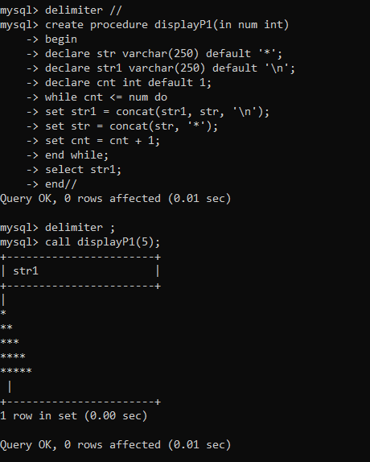
b.
*
***
*****
***
*
drop procedure displayP3;
delimiter //
create procedure displayP3(in num int)
begin
declare str varchar(16383) default '*';
declare str1 varchar(250) default '\n';
declare cnt int default 1;
set cnt= ceil(num/2);

while cnt <= num do
set str1 = concat(str1, lpad(str,cnt,' '), '\n');
set cnt = cnt + 1;
set str = concat(str, '**');
end while;
set cnt = num - 1;
set str = substr(str, 1, num-2);
while cnt >= ceil(num/2) do
set str1 = concat(str1, lpad(str,cnt,' '), '\n');
set str = substr(str, 1, length(str) - 2);
set cnt = cnt - 1;
end while;

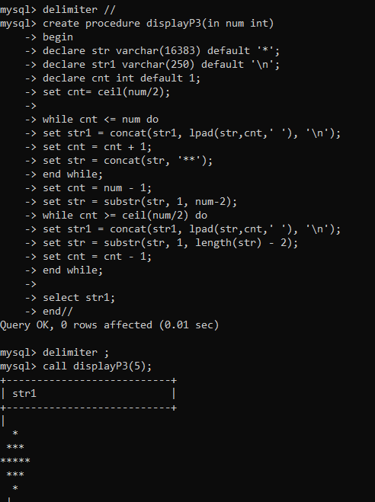
select str1;
end//
delimiter ;
call displayP3(5);

c.
1010101
10101
101
1
d.
1
1 2
1 2 3
1 2 3 4
1 2 3 4 5

delimiter //
create procedure displayP2(in num int)
begin
declare str varchar(250) default '1';
declare str1 varchar(250) default '\n';
declare cnt int default 1;
while cnt <= num do
set str1 = concat(str1, str, '\n');
set cnt = cnt + 1;
set str = concat(str, ' ', cnt);
end while;
select str1;
end//
delimiter ;
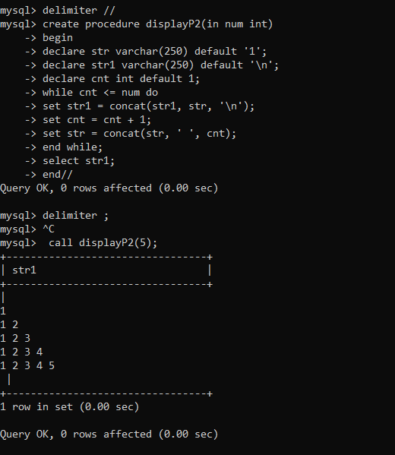
2. write a procedure to insert record into employee table.
the procedure should accept empno, ename, sal, job, hiredate as input parameter
write insert statement inside procedure insert_rec to add one record into table
delimiter //
create procedure insert_rec(
peno int,
pname varchar(20),
psal double(9,2),
pjob varchar(20),
phiredate date
)
begin
insert into emp(empno, ename, sal, job, hiredate)
values(peno, pname, psal, pjob, phiredate);
end//
delimiter ;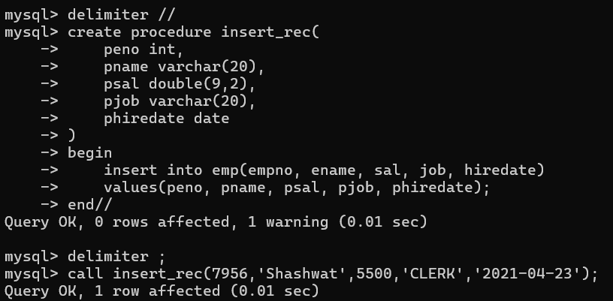

3. write a procedure to delete record from employee table.the procedure should accept empno as input parameter.write delete statement inside procedure delete_emp to delete one record from emptable

delimiter //
create procedure delete_emp(peno int)
begin
delete from emp
where empno = peno;
end//
delimiter ;
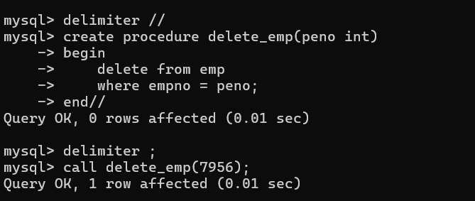
4. write a procedure to display empno,ename,deptno,dname for all employees with sal
> given salary. pass salary as a parameter to procedure
delimiter //
create procedure display_emp_by_sal(psal double(9,2))
begin
select e.empno, e.ename, e.deptno, d.dname
from emp e
join dept d on e.deptno = d.deptno
where e.sal > psal;
end//
delimiter;
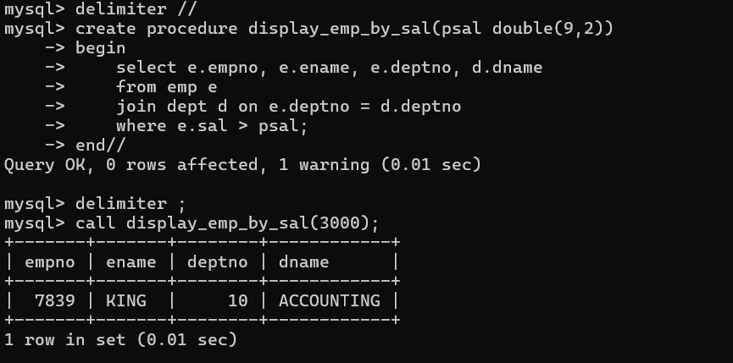

5. write a procedure to find min,max,avg of salary and number of employees in the
given deptno.
deptno --→ in parameter
min,max,avg and count ---→ out type parameter
execute procedure and then display values min,max,avg and count
delimiter //
create procedure display_mix_max_avg(pdptno int)
begin
select max(sal),min(sal),avg(sal), count(*) from emp
where deptno = pdptno
group by deptno;
end//
delimiter ;
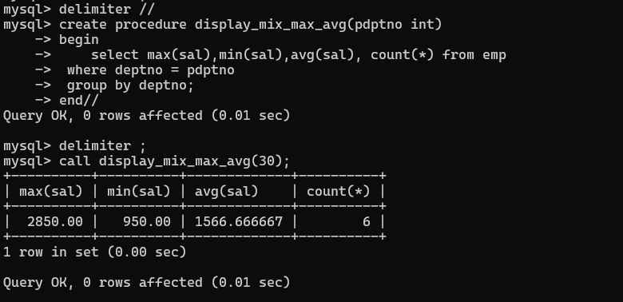
6. write a procedure to display all pid,pname,cid,cname and salesman name(use
product,category and salesman table)
delimiter //
create procedure display_vehicle_product_details()
begin
select
v.Vid ,
v.Vname ,
c.Custid,
c.Cname,
s.Sname as salesman_name
from cust_vehicle cv
join vehicle v on cv.Vid = v.Vid
join customer c on cv.Custid = c.Custid
join salesman s on cv.Sid = s.Sid;
end//
delimiter ;
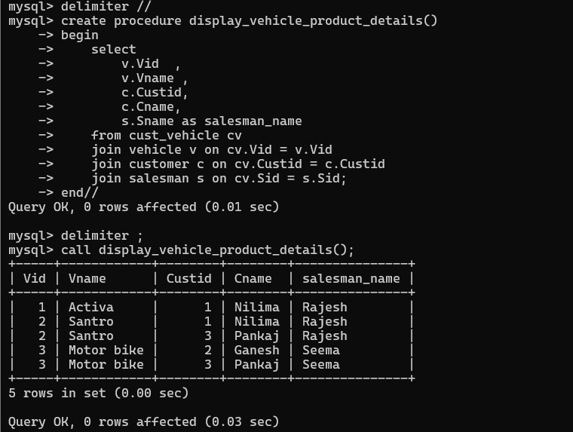

7. write a procedure to display all vehicles bought by a customer. pass customer name
as a parameter.(use vehicle,salesman,custome and relation table)

delimiter //
create procedure display_vehicles_by_customer(p_custname varchar(50))
begin
select
c.Cname,
v.Vid,
v.Vname,
v.Price,
s.Sname as Salesman,
cv.Buy_price
from cust_vehicle cv
join customer c on cv.Custid = c.Custid
join vehicle v on cv.Vid = v.Vid
join salesman s on cv.Sid = s.Sid
where c.Cname = p_custname;
end//
delimiter ;
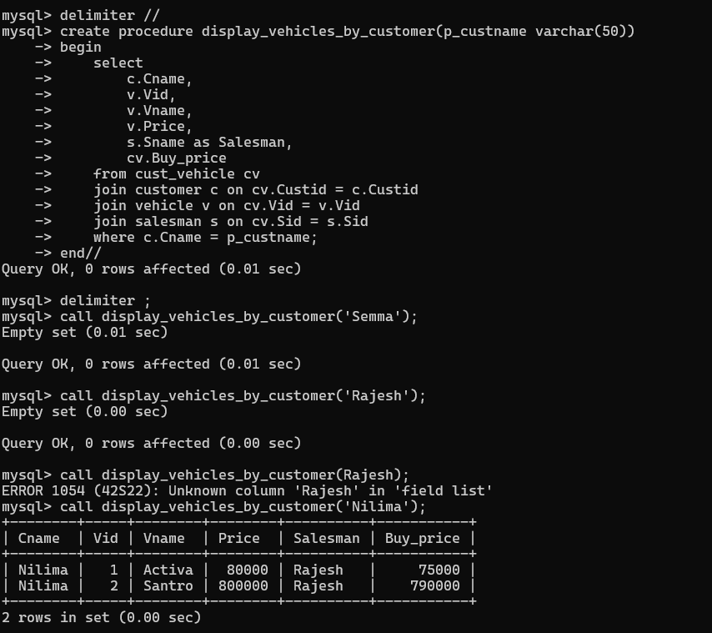

8. Write a procedure that displays the following information of all emp
Empno,Name,job,Salary,Status,deptno
Note: - Status will be (Greater, Lesser or Equal) respective to average salary of their own
department. Display an error message Emp table is empty if there is no matching
record.
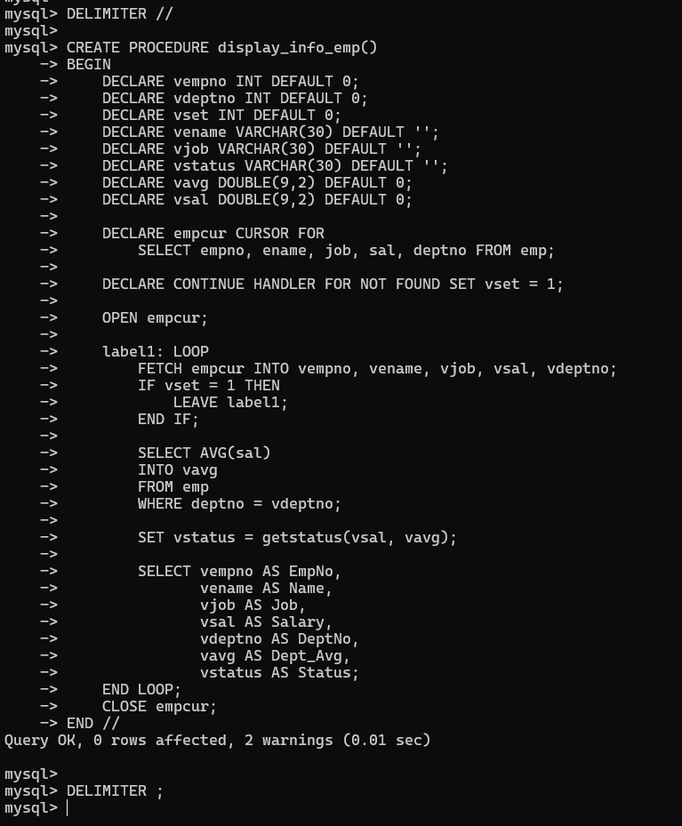
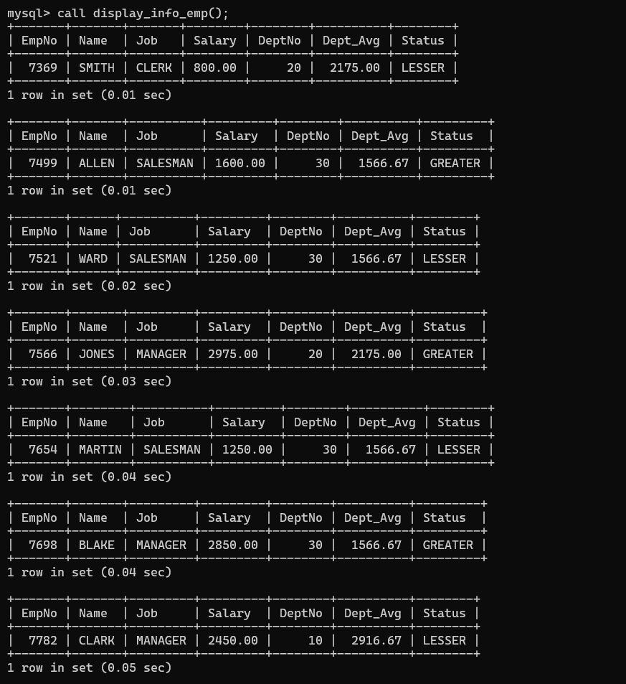
9. Write a procedure to update salary in emp table based on following rules.
Exp< =35 then no Update
Exp> 35 and <=38 then 20% of salary
Exp> 38 then 25% of salary

DELIMITER //
CREATE PROCEDURE updatesal()
BEGIN
DECLARE vempno INT;
DECLARE vdeptno INT;
DECLARE vexp INT;
DECLARE vename VARCHAR(30);
DECLARE vsal DOUBLE(9,2);
DECLARE vhdt DATE;
DECLARE vset INT DEFAULT 0;
DECLARE empsalcur CURSOR FOR
SELECT empno, ename, sal, deptno, hiredate FROM emp;
DECLARE CONTINUE HANDLER FOR NOT FOUND SET vset = 1;
OPEN empsalcur;
emp_loop: LOOP
FETCH empsalcur INTO vempno, vename, vsal, vdeptno, vhdt;
IF vset = 1 THEN
LEAVE emp_loop;
END IF;
SET vexp = calexp(vhdt);
IF vexp > 35 AND vexp <= 38 THEN
UPDATE emp SET sal = sal * 1.20 WHERE empno = vempno;
ELSEIF vexp > 38 THEN
UPDATE emp SET sal = sal * 1.25 WHERE empno = vempno;
END IF;
END LOOP;
CLOSE empsalcur;
END //
DELIMITER ;
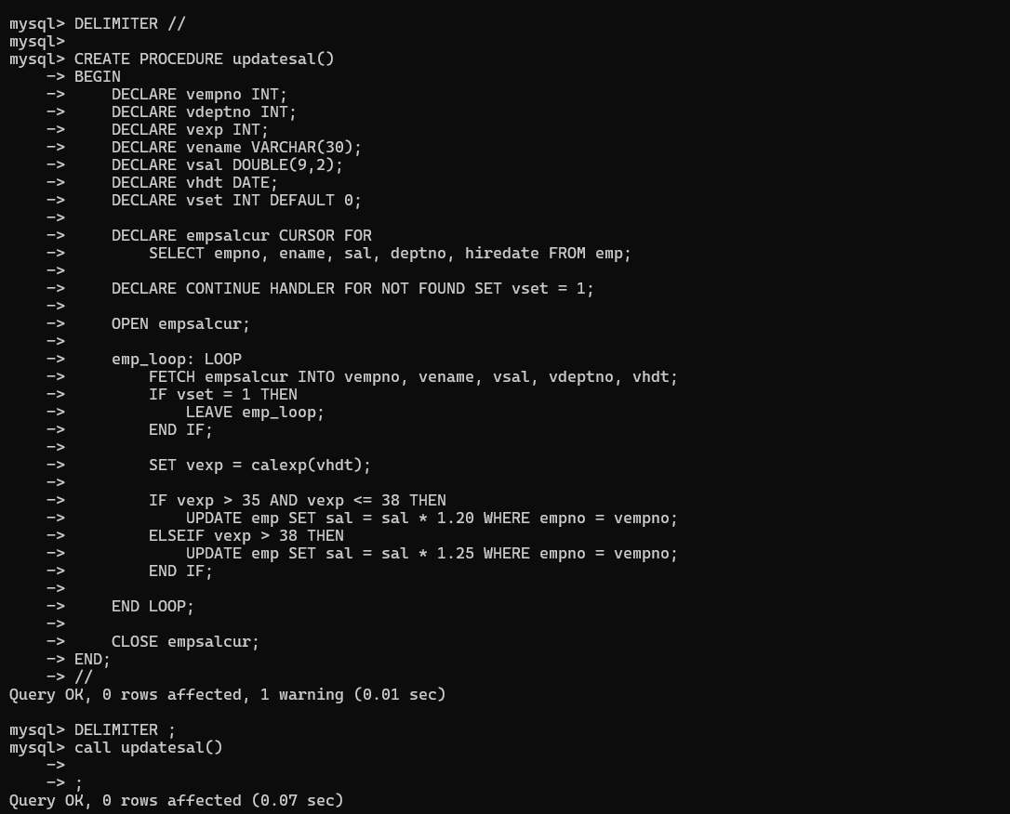

10. Write a procedure and a function.
Function: write a function to calculate number of years of experience of employee.(note:
pass hiredate as a parameter)
Procedure: Capture the value returned by the above function to calculate the additional
allowance for the emp based on the experience.
Additional Allowance = Year of experience x 3000
Calculate the additional allowance
and store Empno, ename,Date of Joining, and Experience in
years and additional allowance in Emp_Allowance table.
create table emp_allowance(
empno int,
ename varchar(20),
hiredate date,
experience int,
allowance decimal(9,2));

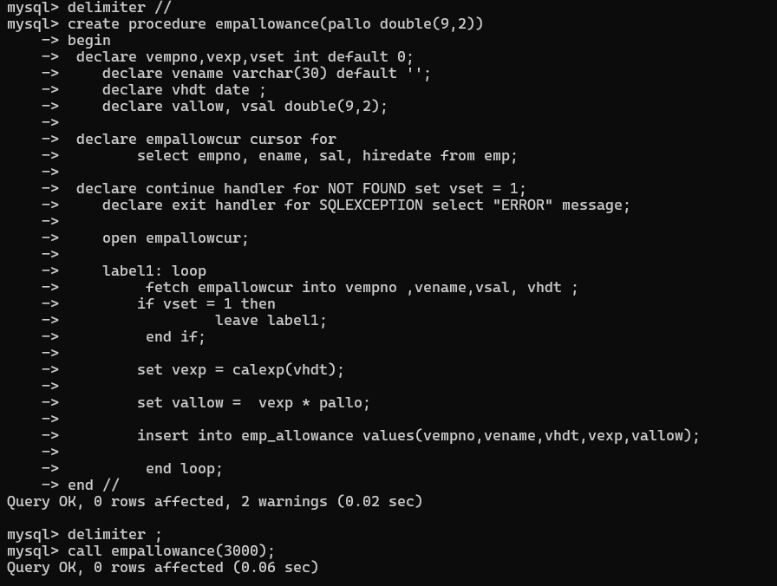
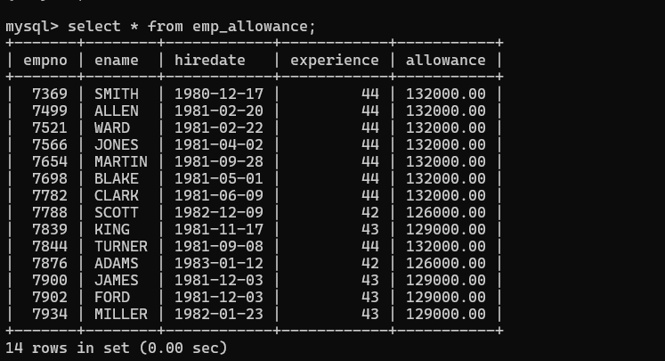

11. Write a function to compute the following. Function should take sal and hiredate
as i/p and return the cost to company.

DA = 15% Salary, HRA= 20% of Salary, TA= 8% of Salary.
Special Allowance will be decided based on the service in the company.
< 1 Year Nil
>=1 Year< 2 Year 10% of Salary
>=2 Year< 4 Year 20% of Salary
>4 Year 30% of Salary
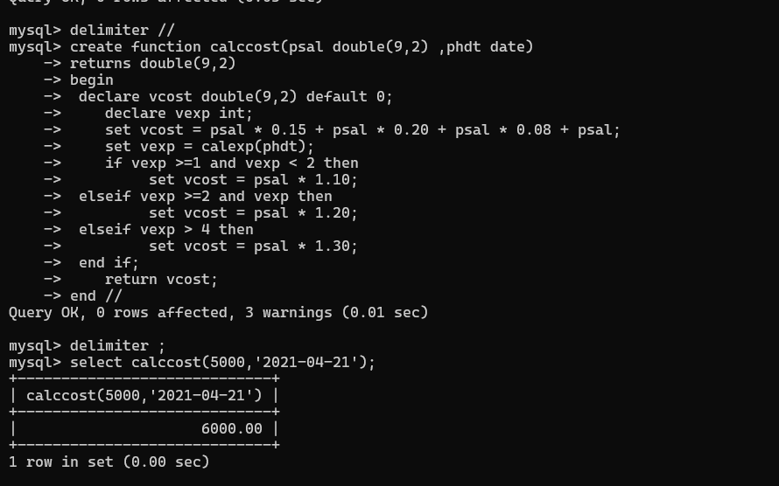

12. Write query to display empno,ename,sal,cost to company for all employees(note:
use function written in question 10)
